Information for the authors
Each paper has to have abstract (150-250 words), keywords, introduction, objective, methodology, results, discussions, conclusion and references. Authors are requested to:
a)Use single-spaced text throughout the paper.
b) Use a standard font, such as Times New Roman, in a legible size (11-point)
Kindly follow the above mentioned pattern while writing the paper according to Springer guidelines.

Paper title [Paper Title]
First name Last name¹, First name Last name², First name Last name³[Author Name]
1Affiliation name, email address[Author info]
2Affiliation name, email address[Author info]
Abstract: These guidelines provide instructions to format your full paper. Please write directly into the template or copy your finished text into it choosing ‘match destination formatting’. Please use the predefined formatting styles instead of applying your individual settings. The full paper shall be written in compliance with these instructions. Please review this document to learn about the formatting of text, table captions and references. The conference proceedings will be published in an electronic format. The Abstract should be no more than 250 words and one paragraph only.Avoid quotation and citing references in your abstract. [this paragraph is formatted as Abstract]
Keywords: maximum 4 keywords; paper format; instructions; use of template [the keywords are formatted as Keywords]

1.Introduction[this is formatted as Heading 1, Use the decimal system of numbering if your headings are numbered]

It is expected that authors will submit carefully written and proofread material. Careful checking for spelling and grammatical errors should be performed. Papers should clearly describe the background of the subject, the authors’ contribution, including the methods used, results and concluding discussion on the importance of the work from both scholarly and managerial perspectives. [Paragraph]
The Full Paper must be written in English within 11 pt Times New Roman. The text should be justified. The Full Paper including figures, tables and references can have a length of 5 to 7 pages. Papers having length more than 5 pages have to register for extra pages.
1.1 Heading 2
All accepted papers will be published in the online proceedings which will have an ISSN number and be made accessible from the conference website after the conference. Following the conference papers will be given a DOI reference to ensure they are picked up in scholarly web-searches. We aim to produce conference proceedings of a professional and consistent quality, and appreciate you carefully following the instructions outlined in this guide.
1.1.1 Heading 3
Corresponding Author’s contact details
This template document itself uses the same formatting as required for the Conference so your full paper should appear visually very similar. You can access template styles for Titles, paragraphs, and other styles directly from the Quick Style Menu that is part of the Home Menu in Word. You can either write directly into the template or paste your finished text into it and choose ‘match destination formatting’ in the pop-up menu that appears when you paste in text. Do not change the predefined formatting settings in this document (such as paper size, orientation, margins, typeface, size, indents, spacing, headings, etc.).

Text format
A uniform appearance will assist the reader to read paper of the proceedings. It is therefore suggested to authors to use single-spaced text throughout the paper and use a standard font, such as Times New Roman, in a legible size (11-point)
If you are copying and pasting text from another document in which the formatting is different, it’s highly recommended to use the paste special function in MS Word and choosing the "Keep Text Only" option
Page Numbers
Please don’t add any page numbers as they will be added.
Acronyms
All acronyms should be spelled out the first time they are introduced in text or references. Thereafter the acronym can be used if appropriate, e.g. 'The work for the Organization of United Nations (OUN)...'. Subsequently, 'The OUN studies on...', in a reference ... (Organization of United Nations [OUN] 1989).
Equations, tables and figures
Equations must be written preferably with the same word processor used for the rest of the text, without hand written symbols in order to aid legibility. Equations must be numbered sequentially with their numbers in parenthesis and right justified. In Word, Math function of Word 2007 or 2010, MathType, or Microsoft Equation Editor with Word 2003 can be used to create your equations, and insert the graphic into your text file as an object.
Tables and figures must be embedded in the paper text, close to the location of their first appearance. All tables and figures must be referred to in text as follows: Figure 1, Table 1, i.e. 'As seen in Table [or Figure] 1 ...' (not tab., fig. or Fig). All figures must be numbered in the order in which they appear in the paper (e.g. Figure 1, Figure 2). Please ensure that tables do not split over the page. Please do not use Excel to create tables as this can cause problems when converting your tables into the typesetting program and other formats
Titles of tables and figures
Each table should have a descriptive title (using the current style). Each table and/or figure must have a title that explains its purpose without reference to the text. Table legends must be placed above the table; diagram or figure legends below the diagram or figure. Ensure that all figures are cited in the text in sequential order. Do not write “the following figure”. Identify all elements found in the figure in the figure caption and use boxes, circles, etc. as coordinate points in graphs instead of color lines.
Tables should be formatted as Table 1 (below): left justified text for first column and centred columns thereafter, if possible. Only horizontal table grid lines should be used. Add one empty paragraph of the [ Paragraph] style following a table.

Table 1 Table layout. Captions for Tables are placed above.[Table title].
Table Rows[ Table content] | Cell one | Cell two
Second Row | 1 | 2
Third Row | 2 | 3
Fourth Row | 4 | 5

Short quotations within the text should be marked with double quotation marks: Lawson also has a broad understanding of design when he mentions: “Professional designers such as architects, fashion designers and engineers” (Lawson, 2004, p.5). Longer quotations of more than one line should be formatted as below, again within double quotation marks:

“More of the goods and services produced for consumer across a range of sectors can be conceived of as ‘cultural’ goods, in that way they are deliberately inscribed with to generate desire for then amongst the end uses sold to consumers in terms of particular clusters of meaning indicates the increased importance of ‘culture’ to production circulation of a multitude of goods and services.” (du Gay, et al, 1997, p.24) [Long quotation]
Use of Visual Material
Please think carefully about the presentation of any visual material. As the proceedings will be published in digital form you have the opportunity to include good quality colour images or other media files that help to presentyour research and its context.
Where possible please make images:
- Large enough to see clearly;
- Of good resolution (200dpi);
- Optimised to be less than 350Kb;
- Cropped appropriately.
If you are using diagrams, info graphics, or other schematics please ensure that:
- You present information clearly;
- You use the Times new Roman font;
- All text is legible;
Graphics and diagrams should be saved as EPS files with the fonts embedded. Microsoft Office
files (Excel or PowerPoint) can be submitted in the original format (xls, xlsx, ppt, pptx). Scanned
graphics in TIFF format should have a minimum resolution of 1200 dpi.
Photos or drawings with fine shading should be saved as TIFF with a minimum resolution of 300
dpi.
Ensure consistency by using similar sizing and lettering for similar figures. Ideally, you should size figures to fit in the page or column width. For books in Springer’s standard format, the figures should be 78 mm or 117 mm (3 or 4 1/2 inches) wide and not higher than 198 mm (7 3/4 inches).

After you insert an image into your document, select it and use the style named [Picture]. Images are followed by a caption with figures numbered sequentially – Figure 1, Figure 2, etc.
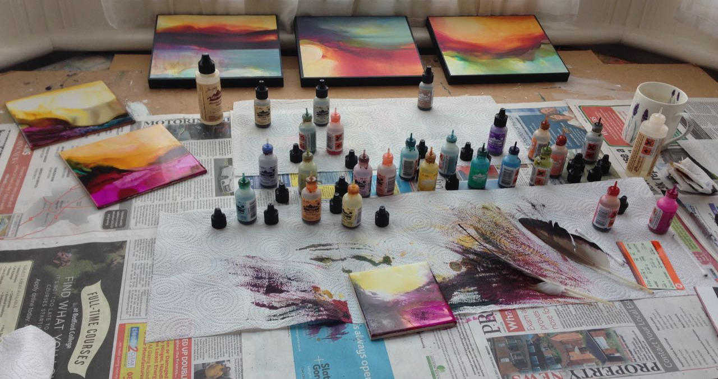
Figure 1 Captions are placed under the pictures. Ensure that your caption adequately describes what you want your reader to see in the picture, highlighting any areas that they should focus on or relationships that you might want them to see.[Caption].

Citations
You can cite with reference numbers in square brackets sequentially by citation like [3, 7, 12].
A reference list should appear at the end of the paper under the heading "References". All the references should be arranged in alphabetical order. Please follow the examples below (cf. References).

Acknowledgements
Any acknowledgements authors wish to make should be included in a separate headed section at the end of the manuscript but before the list of references.

References [please choose reference list]
[For an article in a journal]Goss, R. O., 1990, Economic policies and seaports: strategies for port authorities. Maritime Policy and Management, 17(4), 273-287.
[Book]Frankel, E. G., 1987, The World Shipping Industry (London, U.K.: Croom Helm).
[Chapter in a book]Friesz, T. L., 1981, The multiobjective optimization in transportation: the case of equilibrium network design. In: Organizations: Multiple Agents with Multiple Criteria, edited by J. N. Morse. Lecture Notes in Economics and Mathematical Systems, Vol. 190 (NewYork: Springer-Verlag), pp. 116-127.
[Report, proceedings, and unpublished literature] Asakura, Y., and Sasaki, T., 1990. Formulation and feasibility test of optimal road network design model with endogenously determined travel demand. Proceedings of the 5th World Conference on Transport Research, Yokohama, Japan, July, pp. 351-365.
[Newspaper or magazine] Smith, A., 1996, Labour ditches plans to re-regulate buses. Financial Times, 30 December.
[Internet source (with title, date of access and the universal resource locator in full)] UNO, Charter of the United Nations (Preamble), Date of access: 21/11/2012. http://www.un.org/en/documents/charter/preamble.shtml.
[Government legislation] UNITED KINGDOM PARLIAMENT, Committee on the Working of the Monetary System [Radcliffe Committee] 1960, Principal Memoranda of Evidence , vol. 2, Cmd 1958.

